EXPERIMENT 6

SELECT WITH VARIOUS CLAUSE-BETWEEN,IN,AGGREGATE FUNCTION

**OUTPUTS**

1)

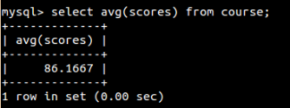

2)

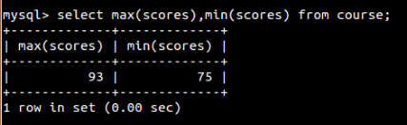

3)

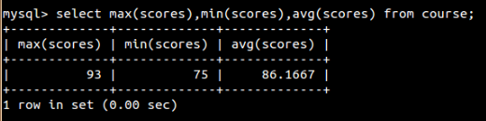

4)

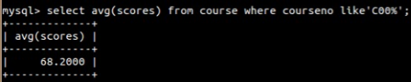

5)

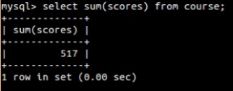

6)

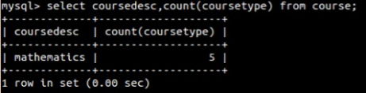

7)

